**Assignment Submission: Web Technologies-I**

**Submitted By:**

* **Name:** Ritik Joshi
* **Symbol Number:** 22530224
* **Semester:** 5th

**Submitted To:**

* **Instructor:** Dipendra Silwal
* **Course:** Web Technologies-I

**Submission Details:**

**GitHub Repository Link:**

<https://github.com/ritikjoshi22/Web-Technology-I/tree/main/assignment-II>

**Site Map:**

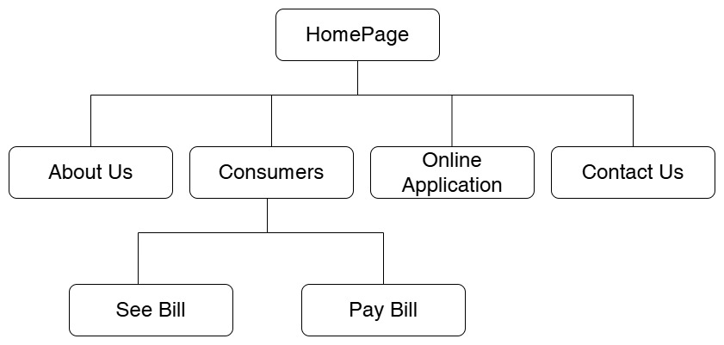

**References:**

1. "HTML5: The Markup Language" - Official W3C Documentation
2. "Introduction to HTML" - MDN Web Docs (<https://developer.mozilla.org/en-US/docs/Web/HTML>)
3. "HTML Basics" - w3schools (https://www.w3schools.com/html/)

**Declaration:**

I declare that this submission is my original work, and I have adhered to the guidelines provided by the instructor for this assignment. All necessary files have been included in the GitHub repository, and references used are cited appropriately.

**Note:**

Please find all the HTML files and images used in the GitHub repository linked above.